Exercise 1: Inventory Management System

Why DSA Matters here: In a modern logistics warehouse handling millions of unique SKU entries, storing data sequentially in an unindexed list requires checking every single slot for updates, collapsing database efficiency from milliseconds to minutes.
Data Structure Trade-offs:
- ArrayList (Sequential Lookup): Adding an item is fast ($O(1)$), but updating or deleting requires scanning through the entire list to find the match, making retrieval an inefficient $O(N)$ operation.
- HashMap (Key-Value Direct Mapping): By mapping a unique key (like productId) directly to a storage bucket using a hashing function, retrieval, updates, and deletions bypass sequential scanning completely, dropping execution overhead to a highly optimal $O(1)$ constant time.

OUTPUT
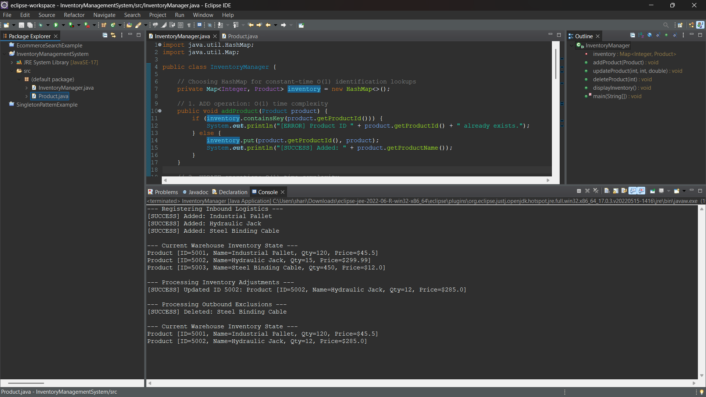

Exercise 2: E-commerce Platform Search Function

Big O Notation: It is a mathematical notation used to describe the upper bound of an algorithm's running time or memory usage in terms of the input size ($N$). It focuses entirely on the worst-case scenario, providing a performance guarantee that your application will never exceed under peak catalog loads.
Search Scenario Breakdown:
- Best-Case: The target element is located at the absolute first index checked. Complexity is $O(1)$ constant time for both searches.
- Average-Case: The position of the target item is distributed across the data structure. Linear search requires looking through $N/2$ items ($O(N)$), while binary search takes approximately $\log_2 N$ steps.
- Worst-Case: The item is at the absolute end of the array, or missing entirely. Linear search maps to $O(N)$, whereas binary search limits checking constraints to a maximum of $O(\log N)$.

OUTPUT
